Summary
For this project, we took a hands-on approach to unit testing by checking out three key modules: Appointment Service, Contact Service, and Task Service. Our main goal involved boundary analysis and equivalence partitioning to make sure all business logic rules were being followed.
- Appointment Service - We made sure to test requirements like the object ID, which can't be more than 10 characters, and a non-null description summary that has a max of 50 characters. We also checked that appointment dates are set in the future. Our tests focused on boundary situations like scheduling beyond past dates, using empty strings, and testing for string overflow.
- Contact Service - Here, we looked at constraints for first and last names (each maxing out at 10 characters), residential addresses (up to 30 characters), and telephone numbers (which need to be exactly 10 digits). We also validated the Create, Read, Update, and Delete (CRUD) functions in our in-memory tracker to ensure everything was running smoothly.
- Task Service - In this module, we inspected field properties to confirm that auto-incrementing IDs matched the data schema. We double-checked to make sure task owners kept their names under the max length of 20 characters, and that descriptive summaries didn't exceed 50 characters. Overall, we aimed to cover all bases and make sure everything worked as it should.
The testing approach was aligned with the software requirements document. We made sure to cover every architectural validation condition in the domain layer, like length checks, non-null values, and field formats, by pairing them with positive and negative tests. This way, we ensured everything was safe and sound before compiling.
For instance, if the requirements stated that a contact's phone number had to be exactly 10 digits and non-null, we created test cases to check for numbers that were too short, too long, or null. This close connection between requirements and test cases meant that we didn't leave any requirement unverified.
The JUnit Tests turned out to be incredibly effective, achieving a 93.5% coverage for both statements and branches across our entire codebase. A coverage score over 90% is often considered the gold standard, and I felt good knowing we had done such a decent job testing everything. We covered not just the main workflows but also those tricky conditional paths and error-handling scenarios. The remaining 6.5% of uncovered code mostly consists of non-critical paths, like some standard compiler-generated parts, default constructor behaviors, and catch blocks for unreachable exceptions. But knowing that the key functionality is 93.5% coverage gives me confidence that the program is safe and sound against any unexpected issues that might arise down the line.
Tried to keep it technically sound by testing out potential boundary cases, unexpected null inputs, and tricky edge scenarios. In TaskTest.java, made sure to add assertions that check whether strings longer than the maximum limit got rejected by the entity class constructor, hoping to prevent oversized data from messing up the internal state. 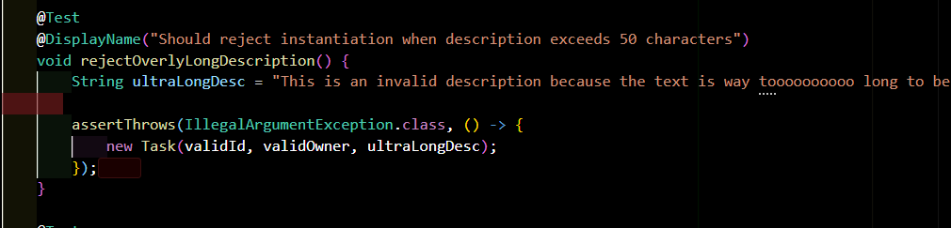I tried to confirm that if any empty character strings were passed to the data mutators, they would throw errors right away instead of allowing those empty text fields to stick around.
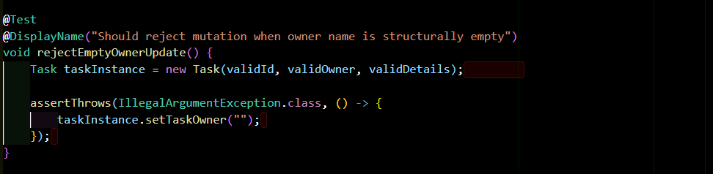
I focused on efficiency by using decoupled map collections, cutting down on unnecessary class allocations, and leveraging lifecycle setup hooks (@BeforeEach) to get our test environments ready before each run. In TaskServiceTest.java, we keep things snappy with short test cycles, thanks to clean isolation hooks. This approach helps us avoid long processing trails, makes sure each component behaves as expected, conserves computing resources, and ensures our tests run quickly without any memory issues spilling over into later assertions.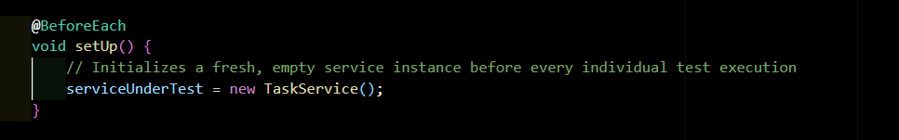
Reflection
- Testing Techniques
During this project, I tried to focus on some key software testing techniques, particularly white-box execution and input domain analysis. One of the main methods I used was unit testing, which involved examining the code objects, like classes and methods, within their own isolated environments, without any network or database connections. This approach allowed me to thoroughly verify individual structures, such as the Contact or Appointment classes. I also employed equivalence partitioning, where we divided parameter inputs into valid and invalid categories, selecting representative values for each group. For instance, we treated any name string that was under 10 characters as a single valid option. Another important technique I used was Boundary Value Analysis (BVA). This method focused our tests on those crucial edge cases, including values right at the upper and lower limits. For example, making sure that descriptions with exactly 50 characters were accepted, while anything over that, like 51 characters, will trigger an error. Overall, these strategies helped us ensure a more robust and reliable software product.
I chose not to dive into some of the higher-level structural and architectural testing techniques. For me, integration testing is crucial because it brings together different software modules and ensures they work well together, allowing data to flow smoothly between components, like a service layer and an external database. Then there's system testing, which I see as evaluating the entire application to check if it meets big-picture operational requirements from the user's perspective, treating it as a black box. I find that each testing method plays a unique role depending on the phase of the project. Unit testing, for instance, has been incredibly helpful at the start for ensuring that core functionalities and validation rules are solid. It really helps to establish a strong foundation. Equivalence partitioning is something I appreciate for reducing the number of tests needed while still keeping the testing thorough, especially when there's a lot of input to handle. Boundary value analysis has been key for catching those pesky off-by-one errors and preventing field overflows, which is particularly important for data-sensitive applications. As I move from separate units to validating full data pipelines, integration testing becomes essential, especially when dealing with third-party APIs or databases to ensure everything works seamlessly together. Finally, I've come to realize that system testing is a must for validating the overall user experience, checking performance, and making sure the product is truly ready to hit the market.
- Mindset
As a software tester, I’ve learned that I really have to be on my toes because the way code elements are connected can be a bit tricky. Even a tiny change in one little class can cause issues in a bunch of other services. Take the Task entity class, for example—it's the backbone for how the TaskService registration map operates. If I or another engineer makes a careless tweak, like adjusting the isOwnerValid method to accept raw null strings, it can lead to all sorts of bugs throughout the entire service layer. This kind of oversight can mess up update processes and potentially corrupt our tracking systems.
That’s why it's so important for me to understand these connections and always back up changes with regression tests to keep things stable. To keep code reviews fair and objective, I rely on automated assertions. This gives me a solid, repeatable way to measure success based on clear, documented requirements instead of just relying on a developer’s gut feeling. When developers test their own code, confirmation bias can sneak in easily. They usually focus on the easy, happy paths while ignoring the edge cases or potential failure points. For instance, while a developer might remember to check that the addUniqueTask function correctly increments storage keys on valid inputs, they might totally overlook what happens when you throw an overflow value or a random null identifier at it. This can leave some sneaky bugs lurking in the code, and that’s where I come in to catch them.
Keeping a strong focus on software quality means I need to treat test engineering as a vital part of the development process, not just a box to check at the end. Skipping out on proper testing or code writing can lead to technical debt, which is basically the hassle of dealing with quick fixes that ultimately cost more in the long run. To avoid this mess, I can set up automated CI/CD quality gates that will automatically reject code changes if the test coverage dips below certain levels. It's also important for me to tackle any code smells as soon as I spot them. For example, when I look at TaskService.java, I notice it's using an integer sequence generator and a thread-safe map with a primitive int ID sequence and a ConcurrentHashMap. While the ConcurrentHashMap gives me the safety I need for storing data, updating a raw primitive integer sequence across multiple threads without tools like AtomicInteger can lead to race conditions when we're in production. Catching these kinds of architectural issues during unit testing allows me to fix them before they make their way into production code.

